Steps to launch Hadoop
- Open Virtual Box
- Open Ambari using 127.0.0.1:808 at any browser
- At Ambari, go to File View, create folder at File View name it as onlineretail2
- Open the folder and add the cleaned parquet data into the file
- Open Zappelin using http://localhost:9995/
- Create a new notebook and name it as onlineretail2_1
- After we do the analysis we download the file and it will be save as JSON file
Take note the code can only be open using Hadoop and if we want to change computer, ensure that computer has Hadoop installed.
Now, we are ready to use Zappelin to do EDA on using SQL
Based on below, we have already added OnlineRetail2 folder.
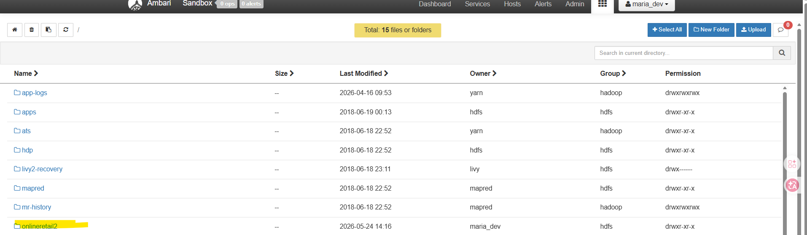

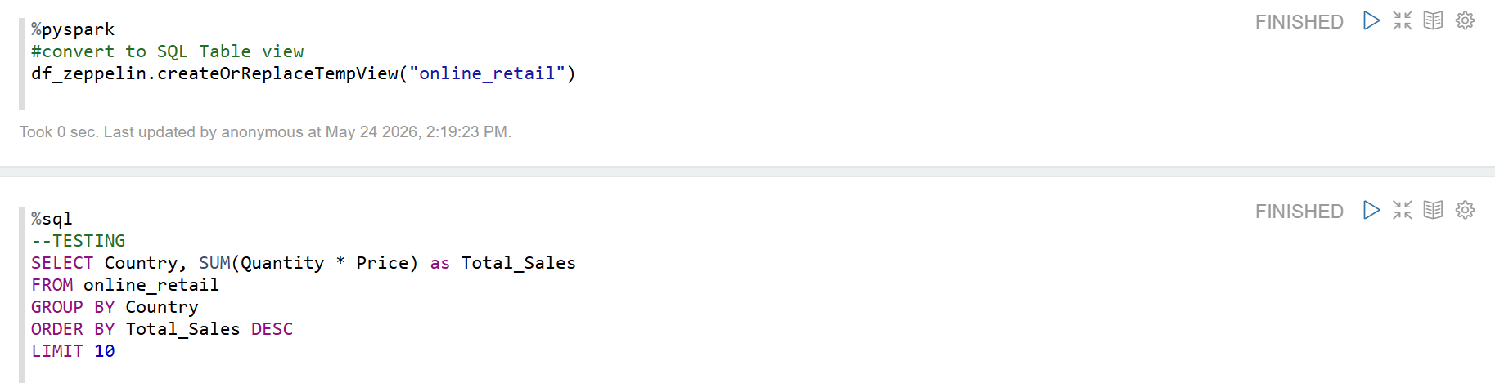
Then, we may try to check the overall sale performance to confirm if our code works for the EDA.

Below are quick snapshot of how the code in Zeppelin looks
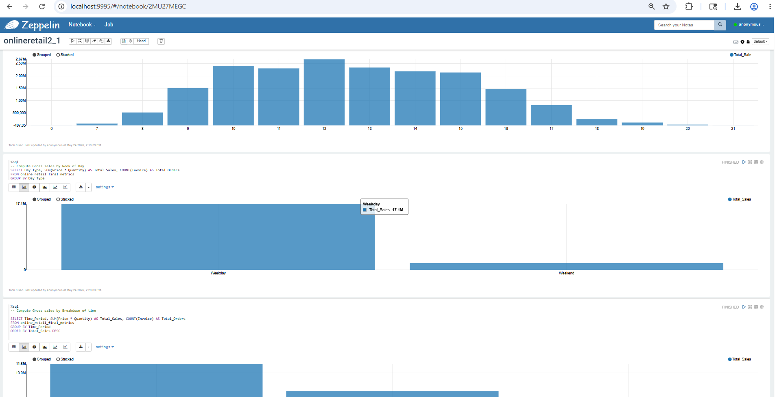

Here is the code we use at the Zeppelin:
%pyspark
#to load data to zeppelin
df_zeppelin = spark.read.parquet("/onlineretail2/onlineretail_ii_1.parquet")
%pyspark
#convert to SQL Table view
df_zeppelin.createOrReplaceTempView("online_retail")
%sql
--TESTING
SELECT Country, SUM(Quantity * Price) as Total_Sales
FROM online_retail
GROUP BY Country
ORDER BY Total_Sales DESC
LIMIT 10
From the code Testing above, we will have a plot as below.
Here is benefit of using the Zeppelin which we can quickly plot EDA without call plot function by clicking the button below and select which graph we like to see
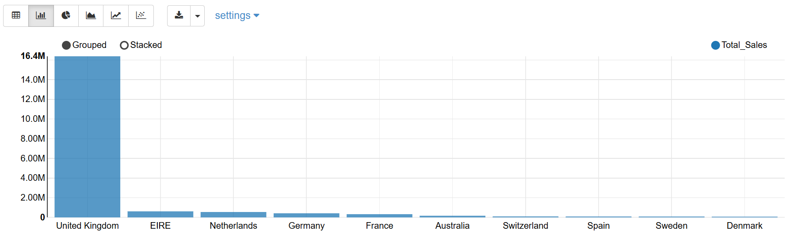

Next we can proceed to do basic data cleaning as below
- Clean the missing value
%sql
--Check Missing Values
SELECT
COUNT(*) - COUNT(Invoice) AS Invoice_null,
COUNT(*) - COUNT(StockCode) AS StockCode_null,
COUNT(*) - COUNT(Description) AS Description_null,
COUNT(*) - COUNT(Quantity) AS Quantity_null,
COUNT(*) - COUNT(InvoiceDate) AS InvoiceDate_null,
COUNT(*) - COUNT(Price) AS Price_null,
COUNT(*) - COUNT(Customer_ID) AS CustomerID_null,
COUNT(*) - COUNT(Country) AS Country_null

FROM online_retail
%sql
--create lookup table to map the description
CREATE OR REPLACE TEMPORARY VIEW stock_desc AS
SELECT
StockCode,
MAX(Description) AS Description
FROM online_retail
WHERE Description IS NOT NULL AND Description != ''
GROUP BY StockCode

%sql
--impute the missing value
CREATE OR REPLACE TEMPORARY VIEW online_retail_cleaned AS
SELECT
main.Invoice,
main.StockCode,
COALESCE(
NULLIF(main.Description, ''),
lookup.Description,
'NA'
) AS Description,
main.Quantity,
main.InvoiceDate,
main.Price,
main.Customer_ID,
main.Country
FROM online_retail main
LEFT JOIN stock_desc lookup

%sql
--review
SELECT COUNT(*) AS remaining_missing_descriptions
FROM online_retail_cleaned
WHERE Description IS NULL OR Description = ''

%sql
-- Check if description ada unique ke
SELECT
StockCode,
COUNT(DISTINCT Description) AS Total_Unique_Descriptions,
COLLECT_SET(Description) AS List_Of_Descriptions
FROM online_retail_final_metrics
GROUP BY StockCode
HAVING COUNT(DISTINCT Description) > 1

We noticed there are multiple product name at same SKUcode, so we clean it using Jupyter Notebook and re-upload cleaned parquet data to the Ambari.

- Check Missing Value
%sql
-- check rows with duplicates
SELECT
Invoice,
StockCode,
Description,
Quantity,
InvoiceDate,
Price,
Customer_ID,
Country,
COUNT(*) as row_count
FROM online_retail_cleaned
GROUP BY
Invoice,
StockCode,
Description,
Quantity,
InvoiceDate,
Price,
Customer_ID,
Country
HAVING COUNT(*) > 1

%sql
-- sum the total number of duplicate rows
WITH duplicated_groups AS (
SELECT COUNT(*) as row_count
FROM online_retail_cleaned
GROUP BY
Invoice,
StockCode,
Description,
Quantity,
InvoiceDate,
Price,
Customer_ID,
Country
HAVING COUNT(*) > 1)
SELECT SUM(row_count) AS total_duplicate_rows
%sql
-- Drop duplicates & simpan ke dalam view baru yang bersih
CREATE OR REPLACE TEMPORARY VIEW online_retail_final AS
SELECT DISTINCT
Invoice,
StockCode,
Description,
Quantity,
InvoiceDate,
Price,
Customer_ID,
Country
FROM online_retail_cleaned

%sql
-- recheck duplicate
WITH duplicated_groups AS (
SELECT COUNT(*) as row_count
FROM online_retail_final
GROUP BY
Invoice, StockCode, Description, Quantity, InvoiceDate, Price, Customer_ID, Country
HAVING COUNT(*) > 1
)
SELECT COALESCE(SUM(row_count), 0) AS total_duplicate_rows
FROM duplicated_groups

- Perform Feature Engineering at Zeppelin
%pyspark
from pyspark.sql import functions as F
#Take clean data
df_clean = spark.table("online_retail_final")

##Feature Enginerring dalam zappelin gune pyspark
df_clean = df_clean.withColumn("Order_Month", F.date_format(F.col("InvoiceDate"), "yyyy-MM")) \
.withColumn("Order_Date", F.to_date(F.col("InvoiceDate"))) \
.withColumn("Order_Hour", F.hour(F.col("InvoiceDate"))) \
.withColumn("Day_Of_Week", F.dayofweek(F.col("InvoiceDate"))) \
.withColumn("Day_Type", F.when(F.col("Day_Of_Week").isin(1, 7), "Weekend").otherwise("Weekday")) \
.withColumn("Time_Period",
F.when((F.col("Order_Hour") >= 5) & (F.col("Order_Hour") < 12), "Morning")
.when((F.col("Order_Hour") >= 12) & (F.col("Order_Hour") < 18), "Afternoon")
.when((F.col("Order_Hour") >= 18) & (F.col("Order_Hour") < 23), "Evening")
.otherwise("Late Night")
)

##put as %sql table
df_clean.createOrReplaceTempView("online_retail_final_metrics")

%sql
-- Compute Gross sales by Month
SELECT Order_Month, SUM(Price * Quantity) AS Total_Sale
FROM online_retail_final_metrics
GROUP BY Order_Month
ORDER BY Order_Month
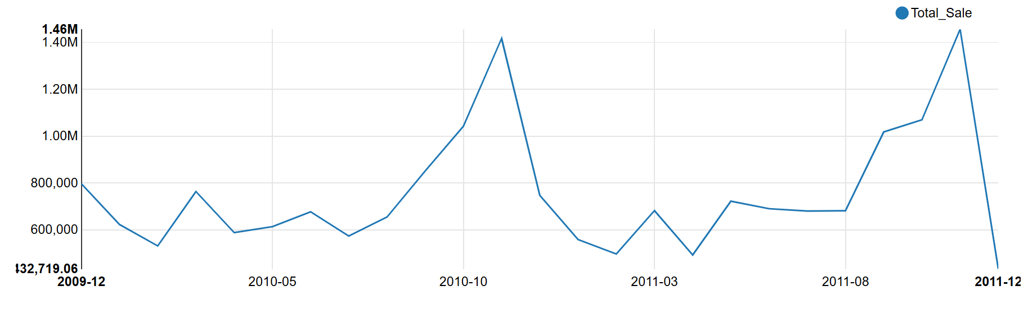

%sql
-- Compute Gross sales by Hour
SELECT Order_Hour, SUM(Price * Quantity) AS Total_Sale
FROM online_retail_final_metrics
GROUP BY Order_Hour
ORDER BY Order_Hour 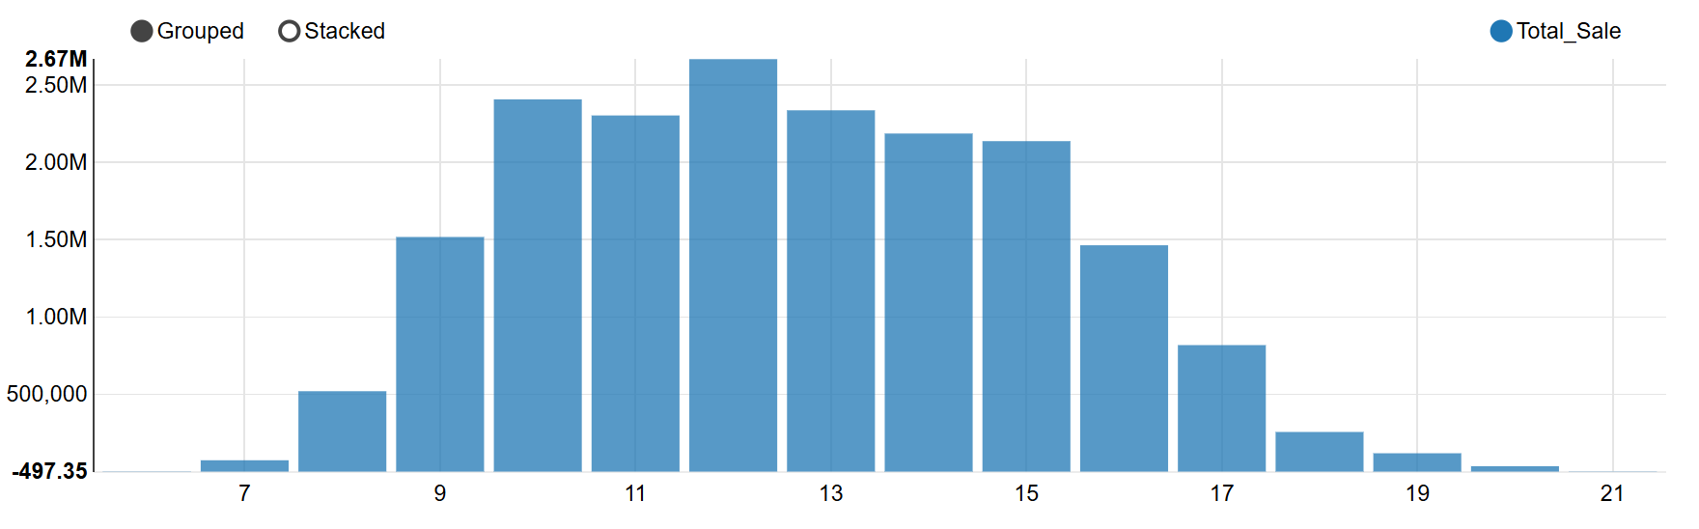
%sql
-- Compute Gross sales by Week of Day
SELECT Day_Type, SUM(Price * Quantity) AS Total_Sales, COUNT(Invoice) AS Total_Orders
FROM online_retail_final_metrics
GROUP BY Day_Type
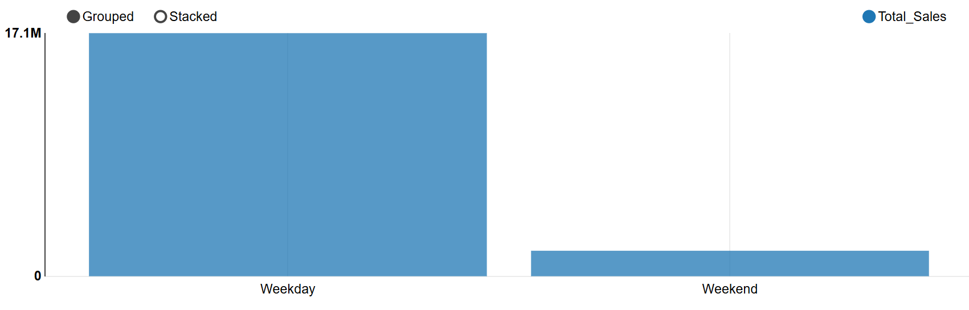
%sql
-- Compute Gross sales by Breakdown of time
SELECT Time_Period, SUM(Price * Quantity) AS Total_Sales, COUNT(Invoice) AS Total_Orders
FROM online_retail_final_metrics
GROUP BY Time_Period
ORDER BY Total_Sales DESC 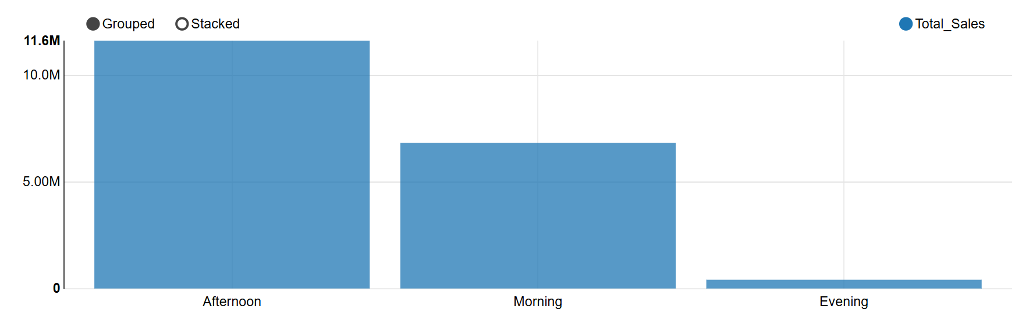

%sql
-- Compute Gross sales by Country (Top 10 Country)
SELECT Country, SUM(Price * Quantity) AS Total_Sale
FROM online_retail_final_metrics
GROUP BY Country
ORDER BY Total_Sale DESC
LIMIT 10 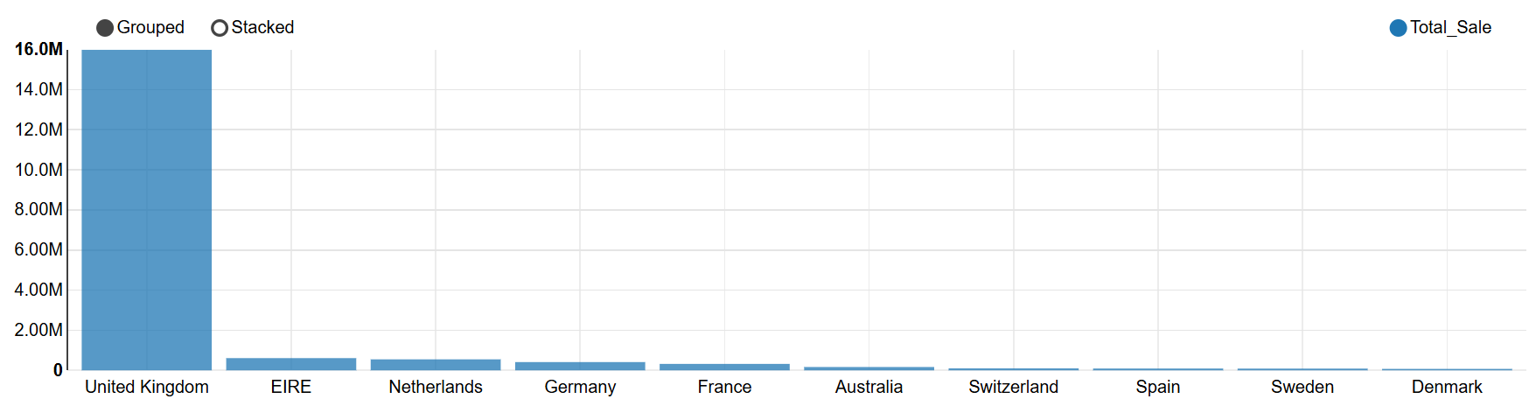

%sql
-- Compute Purchase Trend between country
WITH country_item_sales AS (
SELECT
Country,
StockCode,
MAX(Description) AS Product_Description,
SUM(Quantity) AS Total_Quantity_Sold,
ROW_NUMBER() OVER (PARTITION BY Country ORDER BY SUM(Quantity) DESC) as rank
FROM online_retail_final_metrics
-- Kita tapis keluar kuantiti negatif (pembatalan) dan item NA jika ada)
WHERE Quantity > 0 AND Description != 'NA'
GROUP BY Country, StockCode
)
SELECT
Country,
rank,
StockCode,
Product_Description,
Total_Quantity_Sold
FROM country_item_sales
WHERE rank <= 10
ORDER BY Country, rank
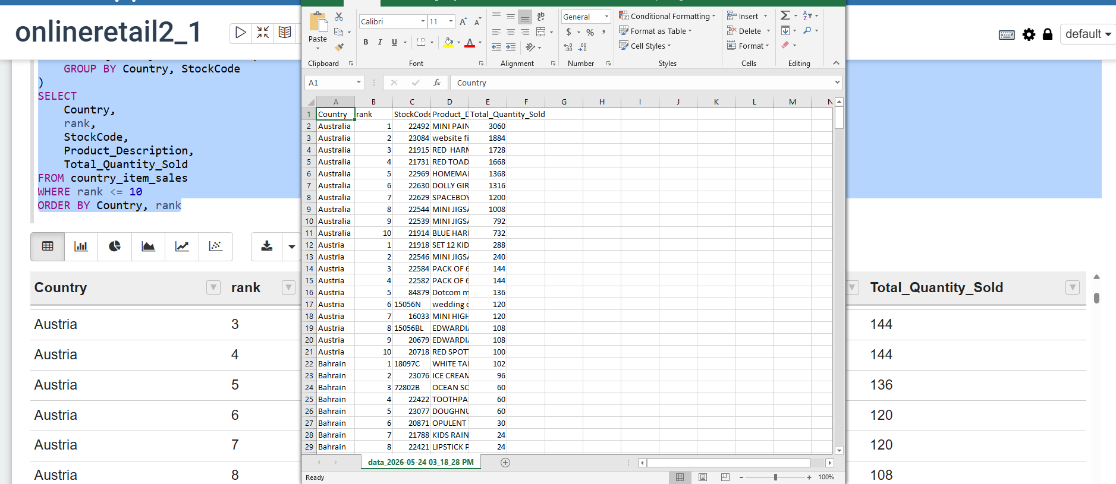
We hardly visualize the performing in graph at Zeppelin interactively by country, so we would view it in table form. We might as well download the table in CSV and upload to Python for review interactively.

%sql
-- Compute Purchase Trend Similarities between country
WITH country_top_10 AS (
SELECT
Country,
StockCode,
MAX(Description) AS Product_Description,
SUM(Quantity) AS Total_Quantity_Sold,
ROW_NUMBER() OVER (PARTITION BY Country ORDER BY SUM(Quantity) DESC) as rank
FROM online_retail_final_metrics
WHERE Quantity > 0 AND Description != 'NA'
GROUP BY Country, StockCode
)
SELECT
StockCode,
MAX(Product_Description) AS Product_Name,
COUNT(DISTINCT Country) AS Number_Of_Countries_As_Top_10,
COLLECT_SET(Country) AS List_Of_Countries
FROM country_top_10
WHERE rank <= 10
GROUP BY StockCode
HAVING COUNT(DISTINCT Country) > 1
ORDER BY Number_Of_Countries_As_Top_10 DESC 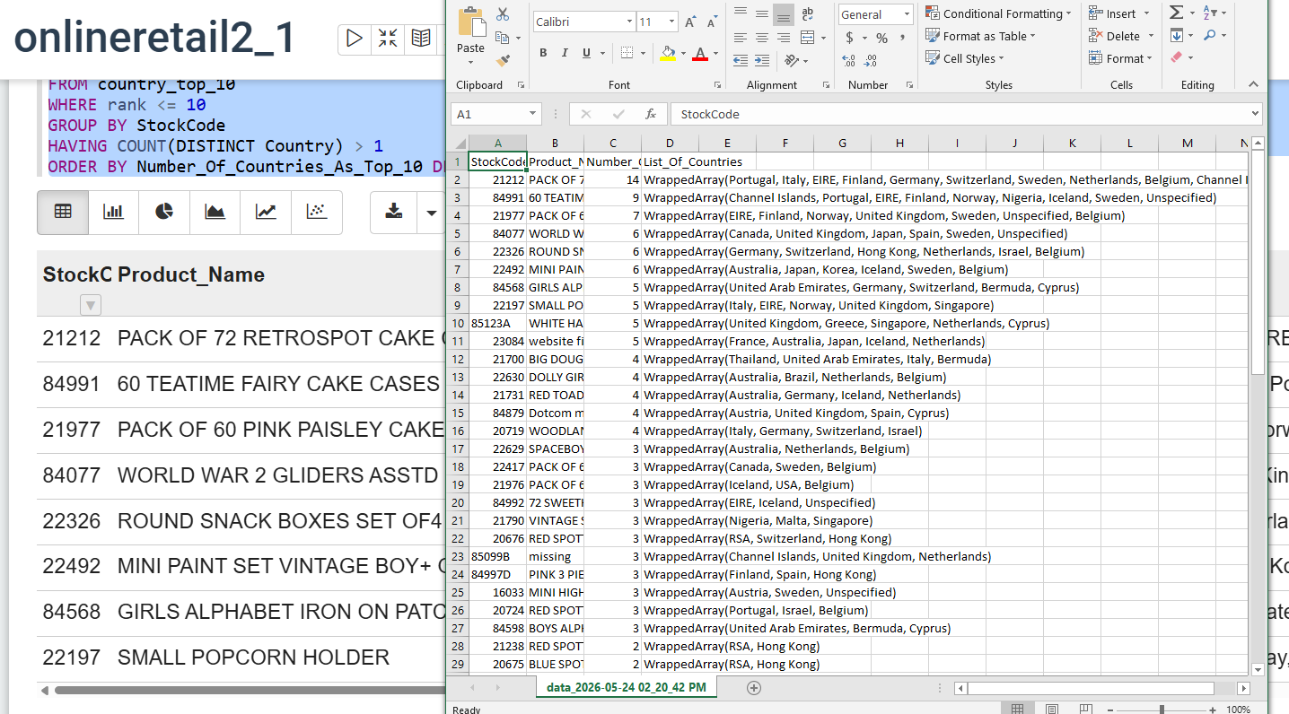

%sql
-- Compute top spender (High Value) customer
SELECT
Customer_ID,
Country,
COUNT(DISTINCT Invoice) AS Total_Orders,
SUM(Quantity) AS Total_Items_Bought,
ROUND(SUM(Price * Quantity), 2) AS Total_Amount_Spent
FROM online_retail_final_metrics
WHERE Customer_ID IS NOT NULL
AND Price > 0
AND Quantity > 0
GROUP BY Customer_ID, Country
ORDER BY Total_Amount_Spent DESC
LIMIT 10
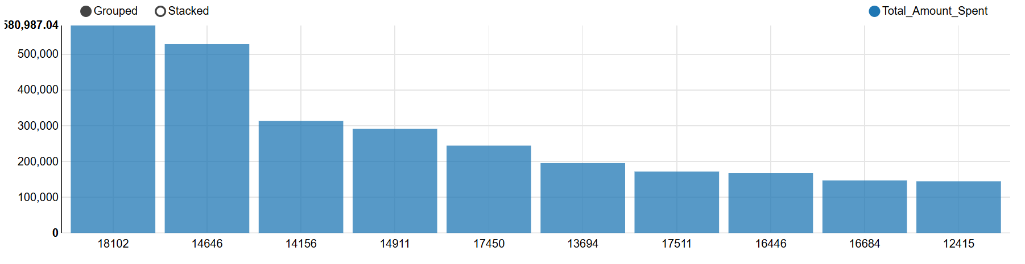

%sql
-- Compute AOV by Country
WITH invoice_totals AS (
SELECT
Country,
Invoice,
SUM(Price * Quantity) AS Invoice_Total_Value
FROM online_retail_final_metrics
WHERE Price > 0 AND Quantity > 0
GROUP BY Country, Invoice
)
SELECT
Country,
COUNT(Invoice) AS Total_Invoices,
ROUND(AVG(Invoice_Total_Value), 2) AS Average_Order_Value,
ROUND(SUM(Invoice_Total_Value), 2) AS Total_Country_Revenue
FROM invoice_totals
GROUP BY Country
HAVING Total_Invoices > 10
ORDER BY Average_Order_Value DESC
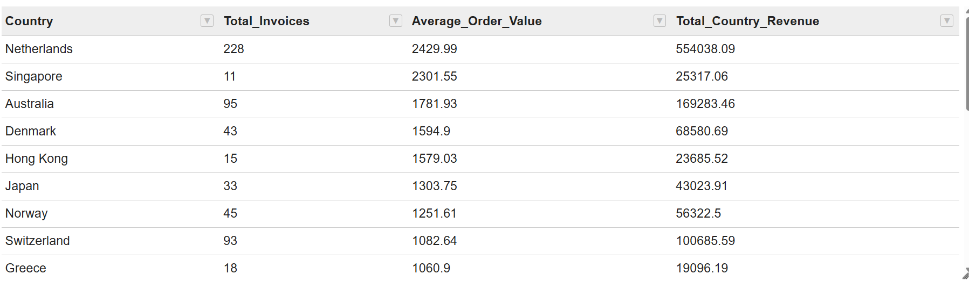

%sql
-- Top Country is UK but Top AOV is Netherland
-- Check if really UK is mostly B2C and Netherland B2B
WITH invoice_summary AS (
SELECT
Country,
Invoice,
SUM(Quantity) AS Total_Items_In_Basket,
SUM(Price * Quantity) AS Invoice_Value
FROM online_retail_final_metrics
WHERE Price > 0 AND Quantity > 0
GROUP BY Country, Invoice
)
SELECT
Country,
COUNT(Invoice) AS Total_Invoices,
ROUND(AVG(Total_Items_In_Basket), 0) AS Avg_Items_Per_Invoice,
ROUND(AVG(Invoice_Value), 2) AS Average_Order_Value
FROM invoice_summary
WHERE Country IN ('United Kingdom', 'Netherlands')
GROUP BY Country

%sql
-- Top purchase item bulk purchase in Netherland
SELECT
StockCode,
MAX(Description) AS Product_Description,
SUM(Quantity) AS Total_Quantity_Sold,
COUNT(DISTINCT Invoice) AS How_Many_Invoices,
ROUND(SUM(Price * Quantity), 2) AS Total_Revenue
FROM online_retail_final_metrics
WHERE Country = 'Netherlands'
AND Quantity > 0
AND Description != 'NA'
GROUP BY StockCode
ORDER BY Total_Quantity_Sold DESC
LIMIT 10
